Project Milestone 1
Student Performance Analysis
Vaishnavi Dacharaju
About the Dataset: The dataset used in this analysis comprises student performance data from a Portuguese secondary school's Portuguese language course. It includes various attributes related to students' socio-demographic background, such as age, gender, family size, parental education level, and their academic performance metrics. Specifically, the dataset covers information on students' grades across multiple periods (G1, G2, G3), as well as factors like study time, absences, and health-related behaviors. This data is valuable for exploring correlations between socio-economic factors and academic outcomes, identifying patterns in student performance over time, and potentially uncovering factors that influence educational achievement. Analysis of this dataset can provide insights into effective educational interventions, personalized learning approaches, and policies aimed at improving student outcomes in secondary education settings.
Student Data:
'data.frame': 649 obs. of 33 variables:
$ school : chr "GP" "GP" "GP" "GP" ...
$ sex : chr "F" "F" "F" "F" ...
$ age : int 18 17 15 15 16 16 16 17 15 15 ...
$ address : chr "U" "U" "U" "U" ...
$ famsize : chr "GT3" "GT3" "LE3" "GT3" ...
$ Pstatus : chr "A" "T" "T" "T" ...
$ Medu : int 4 1 1 4 3 4 2 4 3 3 ...
$ Fedu : int 4 1 1 2 3 3 2 4 2 4 ...
$ Mjob : chr "at_home" "at_home" "at_home" "health" ...
$ Fjob : chr "teacher" "other" "other" "services" ...
$ reason : chr "course" "course" "other" "home" ...
$ guardian : chr "mother" "father" "mother" "mother" ...
$ traveltime: int 2 1 1 1 1 1 1 2 1 1 ...
$ studytime : int 2 2 2 3 2 2 2 2 2 2 ...
$ failures : int 0 0 0 0 0 0 0 0 0 0 ...
$ schoolsup : chr "yes" "no" "yes" "no" ...
$ famsup : chr "no" "yes" "no" "yes" ...
$ paid : chr "no" "no" "no" "no" ...
$ activities: chr "no" "no" "no" "yes" ...
$ nursery : chr "yes" "no" "yes" "yes" ...
$ higher : chr "yes" "yes" "yes" "yes" ...
$ internet : chr "no" "yes" "yes" "yes" ...
$ romantic : chr "no" "no" "no" "yes" ...

Histogram:
# Histograms for numeric variables hist(student_data$age)
Input: hist(student_data$absences)
Output
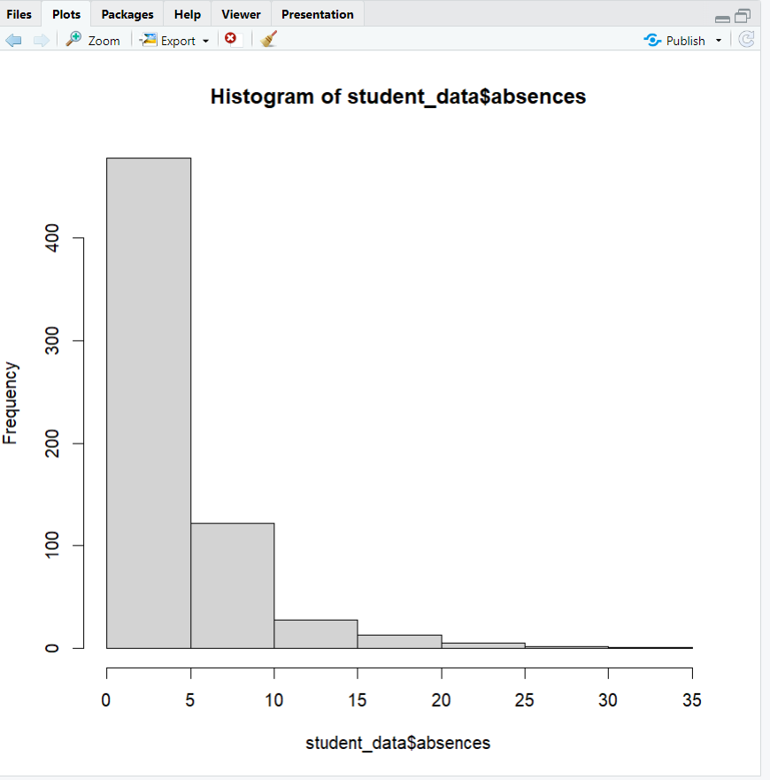

Boxplot: boxplot(student_data$G1, main="Boxplot of G1 Grades")
A boxplot is a graphical representation that summarizes the distribution of a numeric variable. It displays key statistical measures such as the median, quartiles, and potential outliers in a concise manner.

Output:
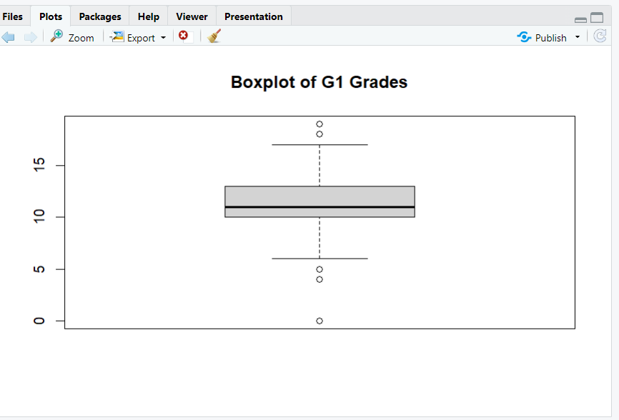

Data Visualization:
Box Plot:
The Box plot analysis between the study time and failures is given below. This is generated by using the code:
Input: boxplot(studytime ~ failures, data=student_data, xlab="studytime", ylab="failure")
Output:
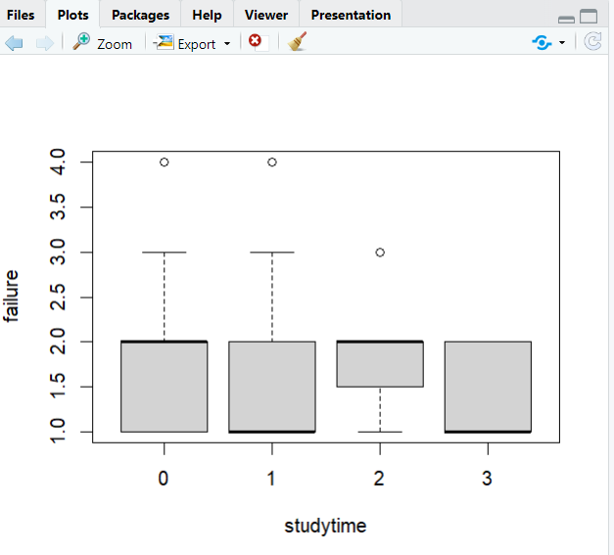

Summary student Data:

school sex age address famsize
Length:649 Length:649 Min. :15.00 Length:649 Length:649
Class :character Class :character 1st Qu.:16.00 Class :character Class :character
Mode :character Mode :character Median :17.00 Mode :character Mode :character
Mean :16.74
3rd Qu.:18.00
Max. :22.00
Pstatus Medu Fedu Mjob Fjob
Length:649 Min. :0.000 Min. :0.000 Length:649 Length:649
Class :character 1st Qu.:2.000 1st Qu.:1.000 Class :character Class :character
Mode :character Median :2.000 Median :2.000 Mode :character Mode :character
Mean :2.515 Mean :2.307
3rd Qu.:4.000 3rd Qu.:3.000
Max. :4.000 Max. :4.000
reason guardian traveltime studytime failures
Length:649 Length:649 Min. :1.000 Min. :1.000 Min. :0.0000
Class :character Class :character 1st Qu.:1.000 1st Qu.:1.000 1st Qu.:0.0000
Mode :character Mode :character Median :1.000 Median :2.000 Median :0.0000
Mean :1.569 Mean :1.931 Mean :0.2219
3rd Qu.:2.000 3rd Qu.:2.000 3rd Qu.:0.0000
Max. :4.000 Max. :4.000 Max. :3.0000
schoolsup famsup paid activities
Length:649 Length:649 Length:649 Length:649
Class :character Class :character Class :character Class :character
Mode :character Mode :character Mode :character Mode :character

nursery higher internet romantic famrel
Length:649 Length:649 Length:649 Length:649 Min. :1.000
Class :character Class :character Class :character Class :character 1st Qu.:4.000
Mode :character Mode :character Mode :character Mode :character Median :4.000
Mean :3.931
3rd Qu.:5.000
Max. :5.000
freetime goout Dalc Walc health
Min. :1.00 Min. :1.000 Min. :1.000 Min. :1.00 Min. :1.000
1st Qu.:3.00 1st Qu.:2.000 1st Qu.:1.000 1st Qu.:1.00 1st Qu.:2.000
Median :3.00 Median :3.000 Median :1.000 Median :2.00 Median :4.000
Mean :3.18 Mean :3.185 Mean :1.502 Mean :2.28 Mean :3.536
3rd Qu.:4.00 3rd Qu.:4.000 3rd Qu.:2.000 3rd Qu.:3.00 3rd Qu.:5.000
Max. :5.00 Max. :5.000 Max. :5.000 Max. :5.00 Max. :5.000
absences G1 G2 G3
Min. : 0.000 Min. : 0.0 Min. : 0.00 Min. : 0.00
1st Qu.: 0.000 1st Qu.:10.0 1st Qu.:10.00 1st Qu.:10.00
Median : 2.000 Median :11.0 Median :11.00 Median :12.00
Mean : 3.659 Mean :11.4 Mean :11.57 Mean :11.91
3rd Qu.: 6.000 3rd Qu.:13.0 3rd Qu.:13.00 3rd Qu.:14.00
Max. :32.000 Max. :19.0 Max. :19.00 Max. :19.00

Head Student Data:

school sex age address famsize Pstatus Medu Fedu Mjob Fjob reason guardian
1 GP F 18 U GT3 A 4 4 at_home teacher course mother
2 GP F 17 U GT3 T 1 1 at_home other course father
3 GP F 15 U LE3 T 1 1 at_home other other mother
4 GP F 15 U GT3 T 4 2 health services home mother
5 GP F 16 U GT3 T 3 3 other other home father
6 GP M 16 U LE3 T 4 3 services other reputation mother
traveltime studytime failures schoolsup famsup paid activities nursery higher internet
1 2 2 0 yes no no no yes yes no
2 1 2 0 no yes no no no yes yes
3 1 2 0 yes no no no yes yes yes
4 1 3 0 no yes no yes yes yes yes
5 1 2 0 no yes no no yes yes no
6 1 2 0 no yes no yes yes yes yes
romantic famrel freetime goout Dalc Walc health absences G1 G2 G3
1 no 4 3 4 1 1 3 4 0 11 11
2 no 5 3 3 1 1 3 2 9 11 11
3 no 4 3 2 2 3 3 6 12 13 12
4 yes 3 2 2 1 1 5 0 14 14 14
5 no 4 3 2 1 2 5 0 11 13 13
6 no 5 4 2 1 2 5 6 12 12 13

Checking for Missing Values:

school sex age address famsize Pstatus Medu Fedu
0 0 0 0 0 0 0 0
Mjob Fjob reason guardian traveltime studytime failures schoolsup
0 0 0 0 0 0 0 0
famsup paid activities nursery higher internet romantic famrel
0 0 0 0 0 0 0 0
freetime goout Dalc Walc health absences G1 G2
0 0 0 0 0 0 0 0
G3
0

